Contributor: Rosa Berland

**Egas, Camilo**

Born: 1899 –Quito, Ecuador; Died: 1962 – New York, New York

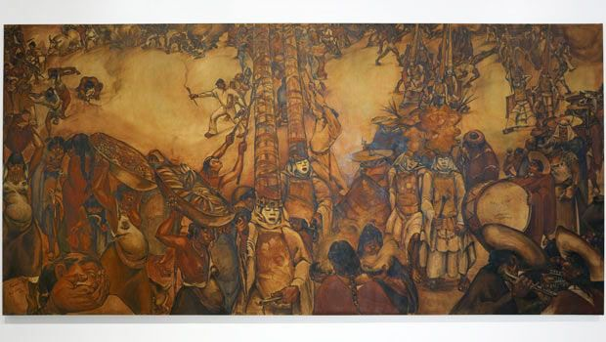

Camilo Egas

*Harvesting Food in North America* and *Harvesting Food in Ecuador: No Profit Motif in Any Face or Figure*, 1932

Mural The New School’s Sheila C. Johnson Design Center, New School for Social Research, New York (<http://www.wnyc.org/story/146104-new-school-unveils-restored-camilo-egas-mural/>)

A leading Ecuadorian modernist, the painter Camilo Egas is associated with the socio-political and artistic indigenismo movement and along with Oswaldo Guayasamín and Eduardo Kingman, considered one of the most important nationalist artists. While always maintaining ties to his native Ecuador, Egas travelled, worked and studied all over the world, beginning his studies at La Escuela de Bellas Artes, Quito, followed by travel to Rome to attend La Regia Accademia di Belle Arti denominata di San Luca (1911-14). He also studied the Academia de San Fernando, Madrid (1920). Before returning to Ecuador, Egas worked in Paris, taking classes at the art school Académie Colarossi (1923) and exhibiting at the Salon des Independents (1924) and in 1925 participating in a number of shows including: Salon d'Automne, Exposition d'Art Américain-Latin, Musée Galliera, Exposition internationale des arts décoratifs et industriels modernes, Salon des Indépendants, Salon d’Automne, and a solo show at Galerie Carmine. Egas returned to Ecuador in 1925 to play an influential role in the formation of a national Indigenist movement, and in 1926 founded Ecuador’s first art periodical*Hélice*. In 1927, the artist settled in New York and became the first director of the Fine Art Department at the New School for whom he would work until 1962.

Egas’ early pictures typically depict scenes of the Indigenous Ecuadorians engaged in everyday activities, ceremonies, and processions, such as the highly stylized *Porters at Rest* (1925) and *Collection of Maize* (1925). Using architectonic forms and rich saturated color, Egas reinterprets the canons of renaissance drawing and the depiction of sculptural form in the heroic tradition of Michelangelo. In addition to this creatively syncretic use of sources and styles, Egas is highly regarded for his mastery of the mural format, particularly his adept translation of avant-garde idioms of European and American art into nationalist narratives that referred to the heritage and Incan history of Ecuador. In 1930 he was commissioned by the New School to paint the murals *Harvesting Food in North America* and *Harvesting Food in Ecuador: No Profit Motif in Any Face or Figur*e (1932). In the impressively dynamic and earth toned Ecuador mural originally in the anteroom to the school dance studio, Egas shows Ecuadorians engaged in a ceremonial dance, wearing traditional costumes, and the *almas* santas as masked dancers*.* Egas imaginatively achieves a centrifugal focus with the vertical division of the picture with impossibly tall ceremonial hats (c*ucuruchos)*. Egas said the work represented a generic indigenous group, and the earth tones reflected the Incan tradition. Other examples of Egas’ murals were included in the 1939 Ecuadorian Pavilion at New York World's Fair and in the late 1930s, Egas also became increasingly interested in motifs from Surrealism as seen in The Museum of Modern Art’s picture *I Dream of Ecuador* (*Ecuadorian Indian)* (1939) and *Civil War in Spain* (1940). The artist’s later work was increasingly Expressionist in style as seen in the painting *Standing Shepherds* (1956).

**Further reading:**

Barr, Alfred H. (1942) Painting and Sculpture in The Museum of Modern Art, The Museum of Modern Art, New York.

Kennedy, A. (1977) Los Signos de/ hombre. Quito, 1985: 251-2. Kennedy, A Historia de/ Arte Ecuatoriano, Quito, 1977: 44-52.

Temporada Cultural Banco Central Del Ecuador. (1979) Camilo Egas. Guayaquil, Ecuador.

"Camilo Egas: Uno de los primeros pintores indigenistas de America." (1941) Vida, Bogota, 5. No. 37, July 1941.

"Camilo Egas." (1959) New School Catalogue, Fall 1959, New York, New York.

"The Indian Influenced Style in Ecuador " (1939) The Studio, November 1939.

**List of Works:**

Camilo Egas *Porters at Rest* (1925), oil on canvas, 73 x 92 cm, Private Collection

Camilo Egas *Collection of Maize* (1925), oil on canvas, 73 x 92 cm, Private Collection

Camilo Egas *Dream of Ecuador (Ecuadorian Indian)* (1939), oil on canvas, 46.3 x 36.5 cm, The Museum of Modern Art, New York

Camilo Egas *Harvesting Food in North America* and *Harvesting Food in Ecuador: No Profit Motif in Any Face or Figure* (1932), murals at The New School’s Sheila C. Johnson Design Center, New School for Social Research, New York

Camilo Egas *Civil War in Spain* (1940) oil on canvas, 43.7 x 46 cm, The Bruce Palmer Gallery, New York

Camilo Egas *Standing Shepherds* (1956), oil on fiberboard, 76.2 x 101.6 cm, Private Collection